~~Equivalent Resistance and current in junction~~

1. 2 pairs of Rs in series and ||

2.

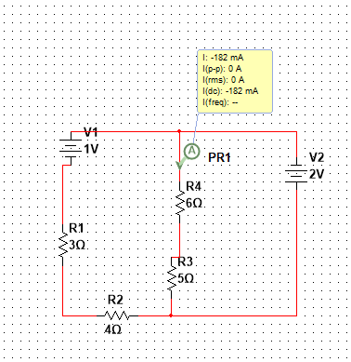

3.

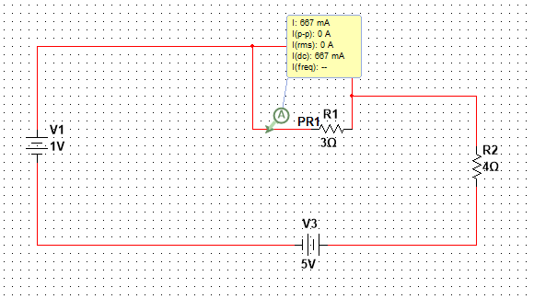

4.

